**1.Describe how sublethaldamage and potentially lethal damage and their repair affect survival curves**

SLDR er kvadratisk is hog PLDR er lineær.

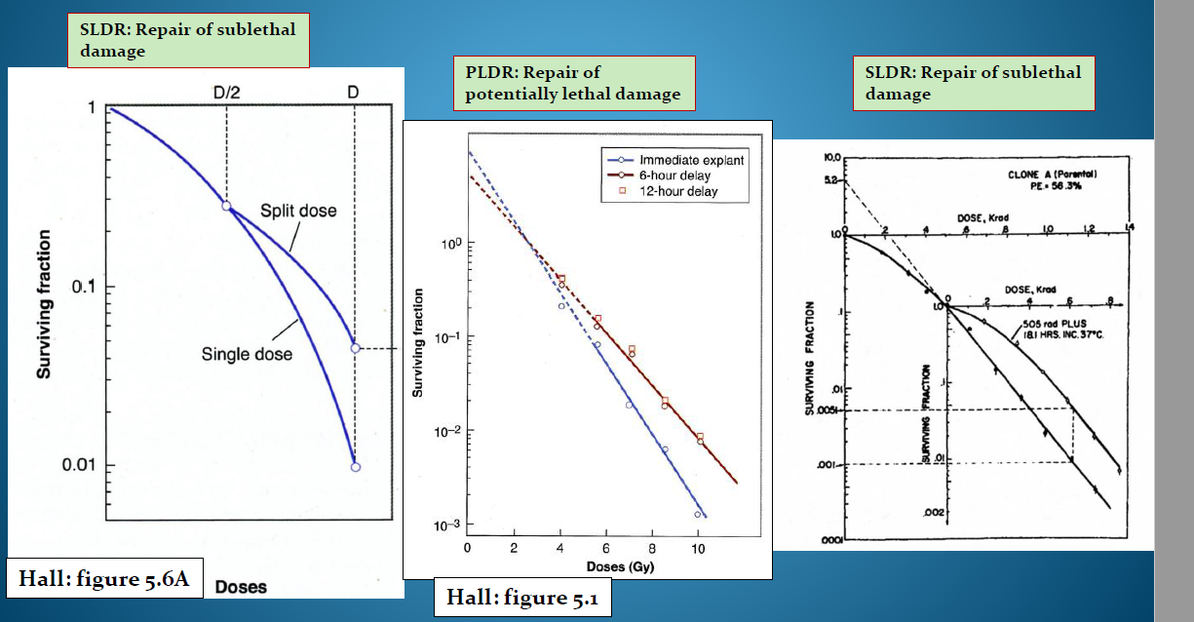

**2.Does tumor or normal tissue have the largest dose-rate effect?**

**3.What is the inverse dose rate effect?**

Mer resistant for høyere dose. Motsatt av det man skulle tro.

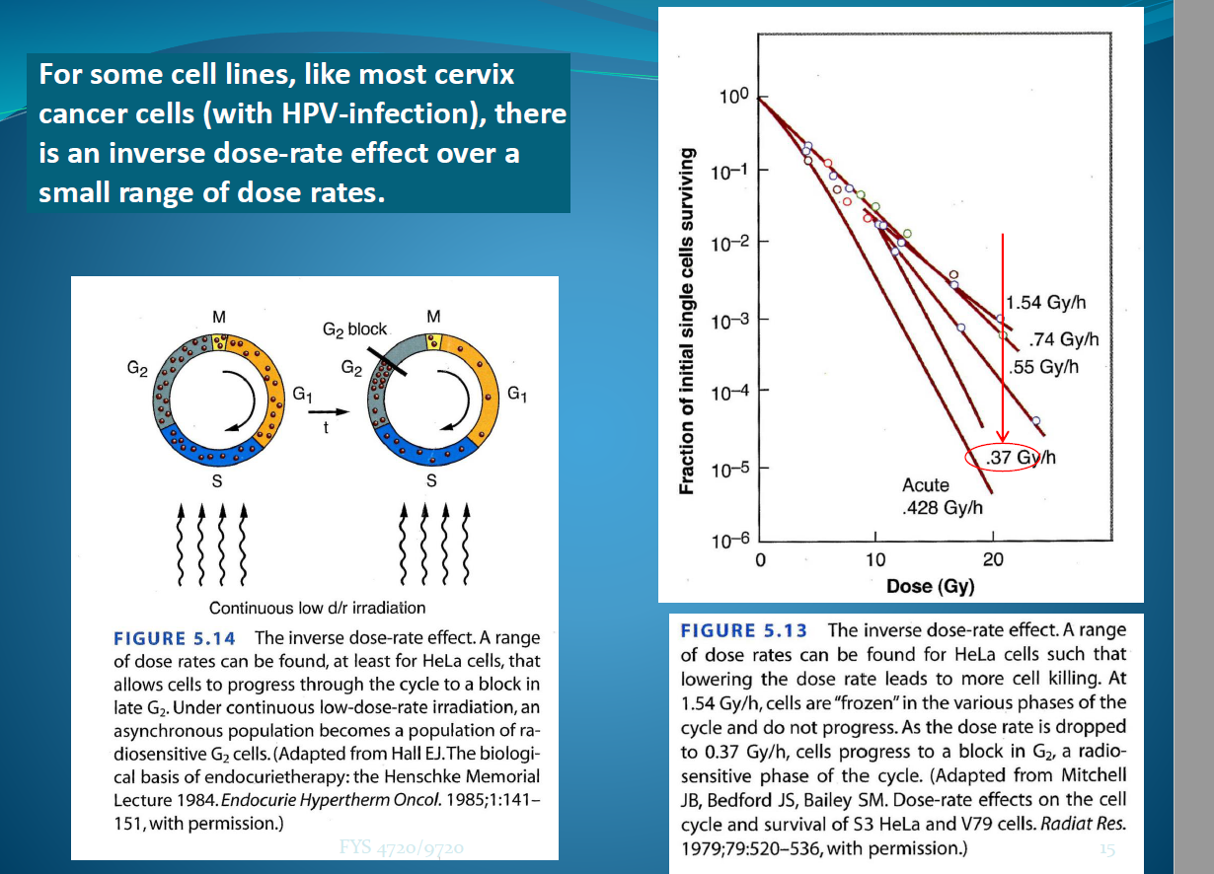

**4.Which type of cells show inverse dose rate effect?**

Cerivix caner cells some

**5.What is the explanation in Hall’s book for the inverse dose rate effect?**

Det skjer en arrest I G2 på grunn av den lave doseraten. De blir synkronisert og blir stående på et radiosensitivt sted i cyklusen. Bilde ovenfor.

**6.Why may that not be the full explanation?**

Kan vær epRB eller p53 eller noe sånn. I G2 pRB som er viktig i arrest i G2.

**7.How can 3 of the 5 R’s be used to explain fractionation effects?**

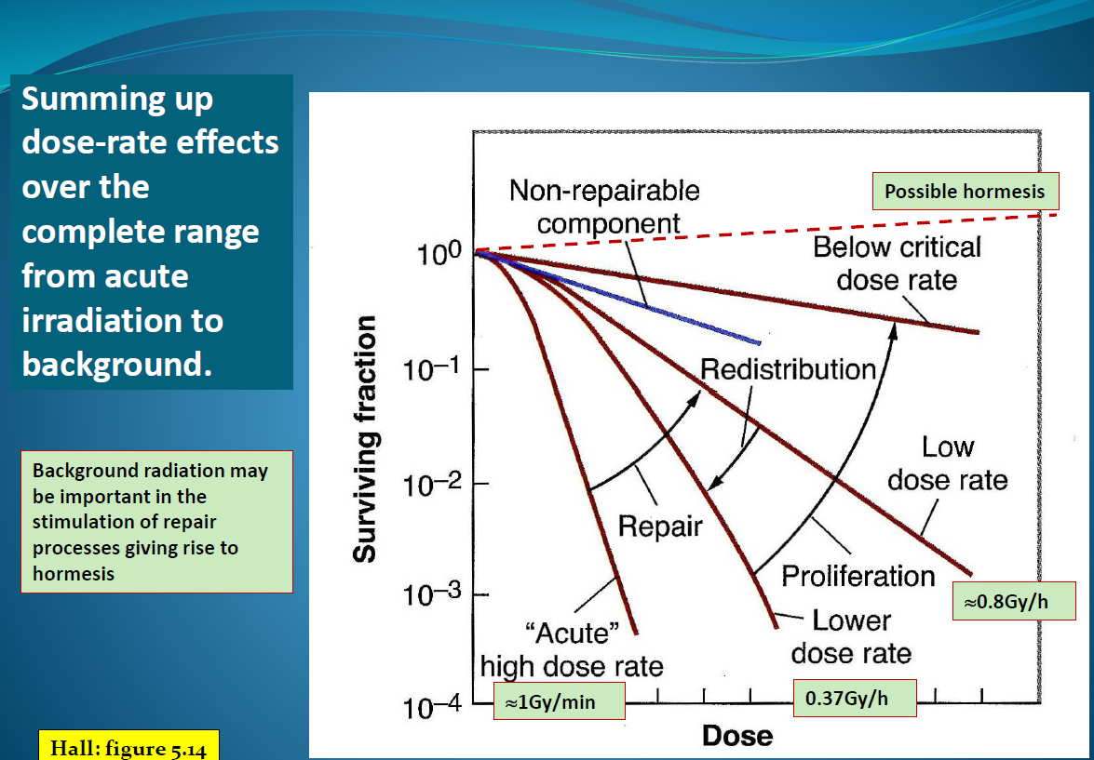

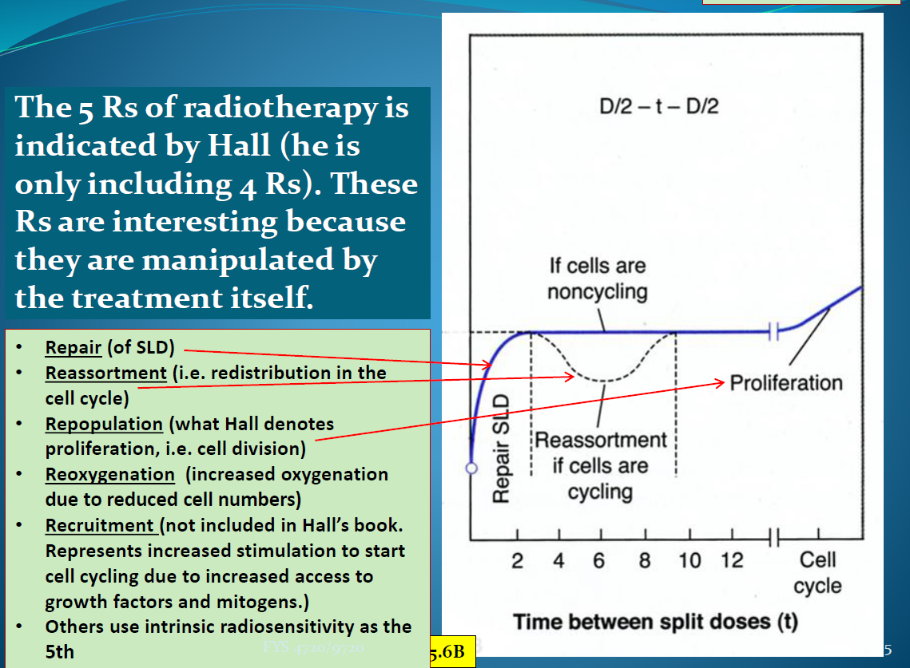

**8.What do we mean by early-and late-responding tissue?**

**9.What is the α/β-ratio?**

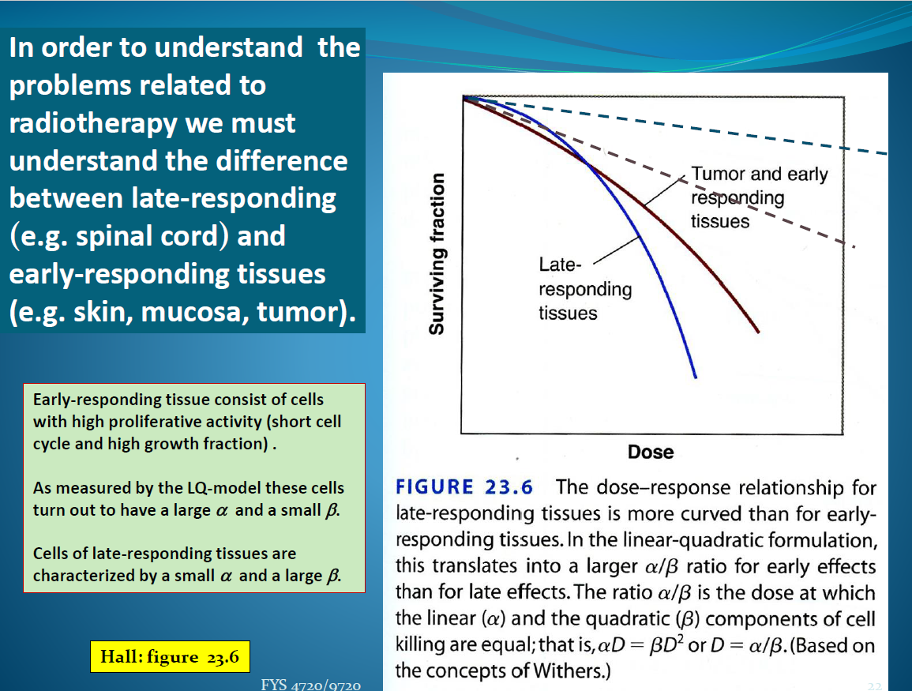

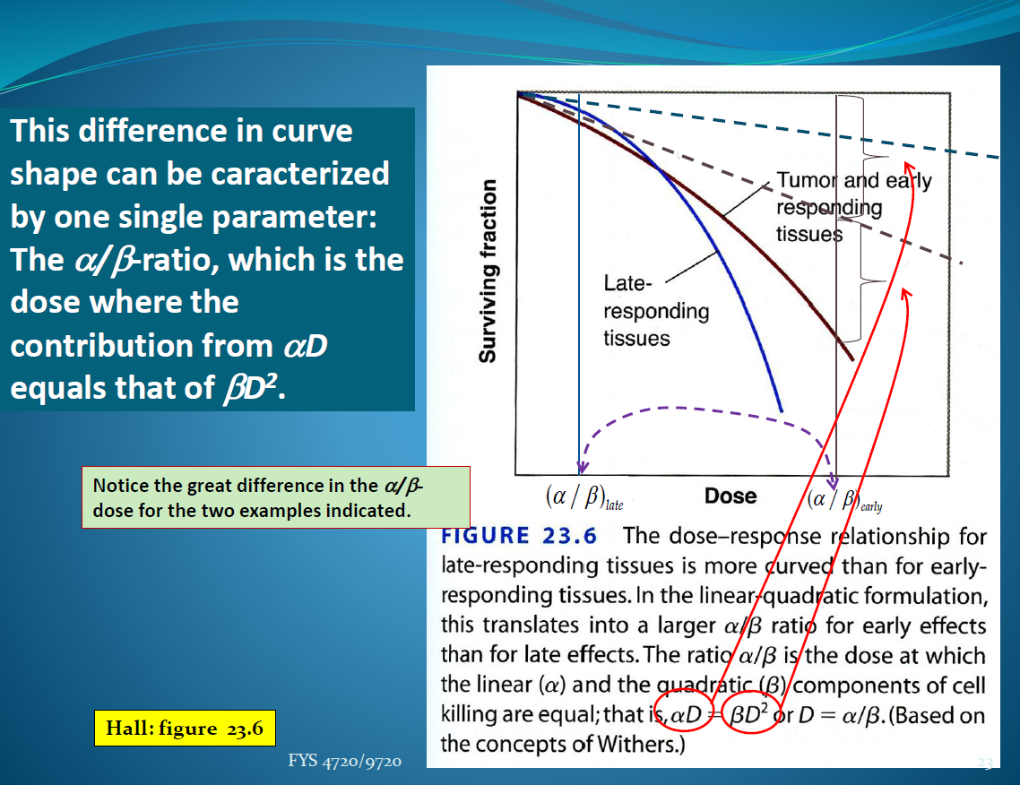

**10.How does the α/β-ratio differ for early-and late-responding tissue?**

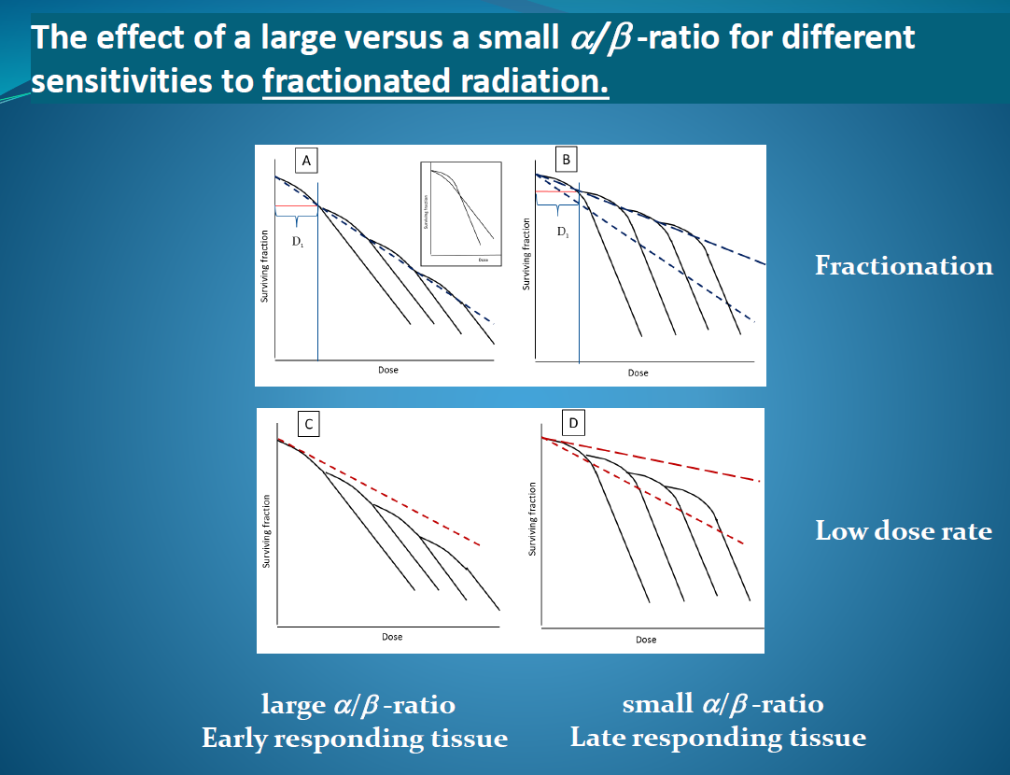**11.How does the difference in α/β-ratio affect the effect of fractionation for early-and late-responding tissue?**

Både fraksjon og doserate gir en lav ab ratio I forhold til earlyresponding.

**12.What are isoeffectdoses?**

Et sted på en graf som viser de identisk effecter, her dosen.

**13.How can the LQ-model be used to evaluate the effects different fractionation regimes (equation)?**

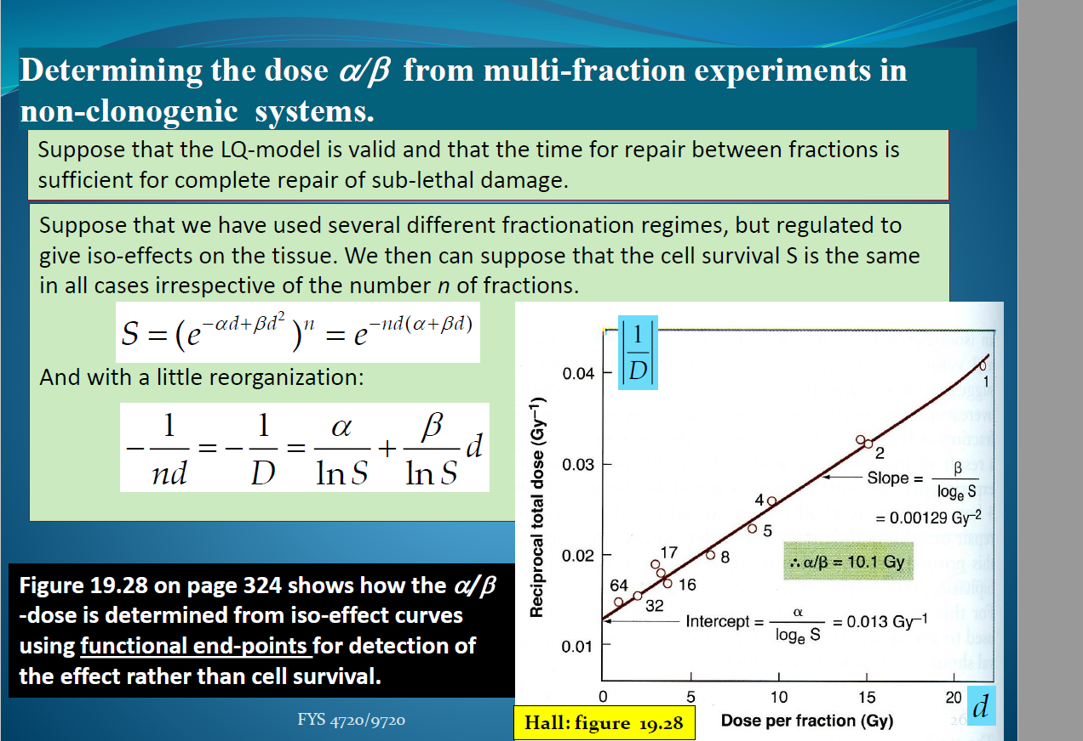

**14.How can we find the α/β-ratio in vivo and how should we plot the data? Se ovenfor**

**15.What do the curves look like that tell us that early-responding tissue start proliferation to compensate for cell loss at an earlier time than late-responding tissue?**

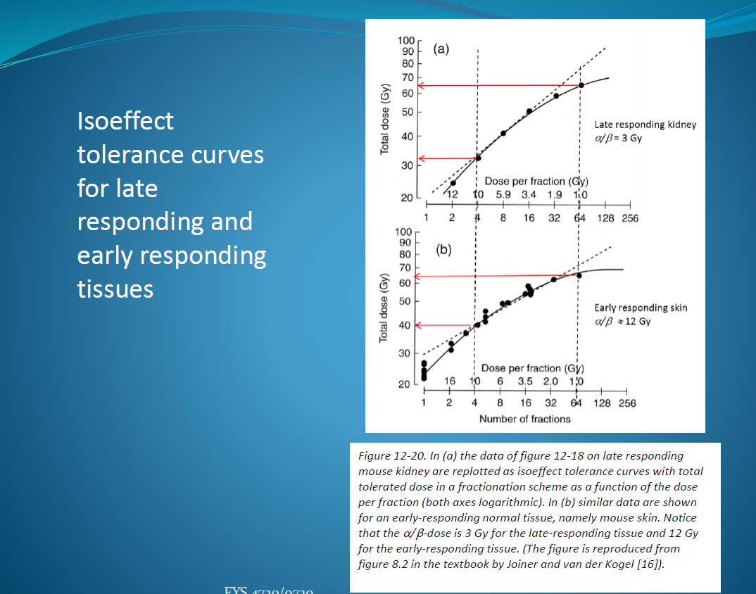

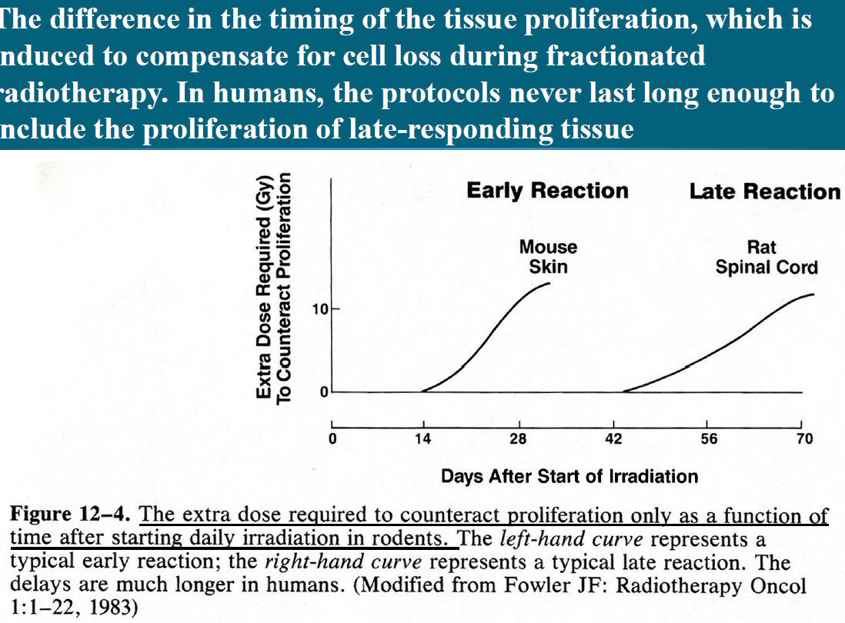

**16.What is Brachytherapy?**

Nære terapi. Det er når noe radioaktivt settes nærme tumor.

**17.What are the two types of Brachytherapy?**

Intracavitary og interstitial. I en åoning eller gjennom huden.

**18.What is the “gold-standard” used as reference for calculations of normal tissue toxicity of Brachytherapy?**

7 dager.

